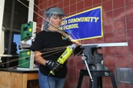
Photo Caption Contest
Post the photo and ask your followers to create their own captions.

Photo 1 – Angelica at Work
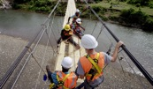
Sparks fly around the fearless Angelica Hernandez while she’s at work in her high school robotics club. Post in the comments how you would caption this photo, and see her in action in #DreamBigFilm.

Photo 2 – Engineers in Haiti
It takes a village to build a bridge. What do you think these Haitian engineers are thinking? Comment and watch them build this bridge from the ground up in @DreamBigFIlm
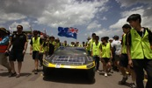
Photo 3 – Solar Car Race
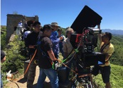
@DreamBigFilm features an epic solar car race across the Australian continent. If you were at the wheel what would be going through your mind? Comment below and see the teams that cross the finish line, powered only by the sun.

Photo 4 – Engineers on Set
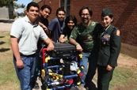
Action! Cinematographer Brad Ohlund positions the @IMAX Camera on the peak of the Great Wall of China while filming @MacGillivray Freeman’s @DreamBigFilm. Caption this photo and see engineering wonders on the only screen giant enough so show them all.

Photo 5 – Stinky’s Team
The robotics team from Carl Hayden High School gather around their underwater robot, Stinky, which they show off in the giant screen doc, @DreamBigFilm. The film highlights engineering projects of all scales. We want to know how you would caption the photo in the comments below!

Photo 6 – Roller Coasters
For engineers, work is play! Testing is an important step in engineering, and roller coaster engineers sure have fun with it! Caption this photo and strap in for a wild ride in @DreamBigFilm.
Photo 7 – Mini Shake Table
How do engineers predict a building’s movement in an earthquake? With marshmallow models! @DreamBigFilm breaks down complex engineering concepts to the nuts and bolts for everyone to enjoy, especially these future builders. What do you think they’re thinking? Comment with your caption below.

